

Fremont Fire Department

Radio Booklet
800 mhz
VHF

Version 2013B
Bendix King Portable Cheat Sheet

Selecting a tone
- Press the number of the tone you want.
- Press [0] to remove your tone selection.

Change Groups
[#] number [ENT]

Switch to Command Group
[#] [#] [ENT]

Add to Command Group
- Select the group/channel you want to add.
- Press [*]

Delete from Command Group
- Select channel (in command group)
- Press [*] or hold [*] to delete all channels

Toggle Switches
To turn on a feature, push the toggle towards it.
- DIR/RPT – Go “direct” (talk-around) or use repeater.
- SCAN – Scan channels within the selected bank.
- PRI – Scan priority channel

Scan List Operation
- Push SCAN and PRI switches to front of radio to turn off scan.
- [ENT] to add selected channel to scan list.
- [CLR] to delete selected channel to scan list.
- Push SCAN towards “Scan” to activate scan.

Lock/Unlock the keypad
Press and hold [FCN]

1 | 110.9 | 2 | 123.0 | 3 | 131.8 | 4 | 136.5
5 | 146.2 | 6 | 156.7 | 7 | 167.9 | 8 | 103.5
9 | 100.0 | 10 | 107.2 | 11 | 114.8 | 12 | 127.3
13 | 141.3 | 14 | 151.4 | 15 | 162.2 | 16 | 192.8

TONE CHART

Bendix King CLONING Cheat Sheet
CLONING PROCEDURE PORTABLE TO PORTABLE

- Place Portable (Master) radio in Program mode (press and hold red button and FCN key until “PSWRD-******” appears).

- Enter “0 0 0 0 0 0”, then ENT.

- Press star (*) Key once. You should see “PROG/GPHCMD” and “Group 15” below.

  - NOTE: You must be in the group you want to clone FROM. If you want to clone from Group 15, you should see “Group 15” below PROG/GPHCMD

- Attach Master Portable to the Clone Mobile, then press “FCN”. The radio should clone.

NOTE: This is for cloning a GPHCMD portable to another GPHCMD portable. If you are trying to clone from a GPHCMD portable to just a GPH portable, see instructions on next page.
Bendix King CLONING Cheat Sheet
CLONING PROCEDURE PORTABLE TO MOBILE

- Place Portable (Master) radio in Program mode (press and hold red button and FCN key until “PSWRD-******” appears).

- Enter “0 0 0 0 0 0”, then ENT.

- Press star (*) Key once. You should see “PROG/GPHCMD” and “Group 15” below.

  - NOTE: You must be in the group you want to clone FROM. If you want to clone from Group 15, you should see “Group 15” below PROG/GPHCMD

- Press and Hold star (*) key until the /GPHCMD becomes /GPH.

  - NOTE: The portable must be in GPH mode to clone to our mobile DMH radios.

- Attach Master Portable to the Clone Mobile, then press “FCN”. The radio should clone.
Kenwood TK-7180 VHF Radio

Kenwood Radio Line up:
Zones are set up the same as the Groups in Bendix/King radio. Zone = Group.

Channel Selection:

Right side ∧ is channel up.
Right side ∨ is channel down.

Zone/Group Selection:

<B button changes zones right-to-left (from F group to A group).
.C> button changes zones left-to-right (from A group to F group).

Tone Guard change/selection:

- Hold down the Red Δ button until the screen says “Tone 1”.
- Push the <B or C> button to change tone.
- Push the “S” button to save selected tone.

Scan:
- You must select channels to be scanned.
  - Turn to the channel you want to scan.
  - Push “A” button to put channel on scan list.
  - Small ▼ appears above channel name (right 2/3 of screen)
  - Push “A” again to delete from scan list.
- Push “S” button to scan.
  - Channel radio was last on before scanning is priority channel.

Talk-a-round (direct radio to radio):
- Push the black square button “ ▀ ”
- Then push the “A” button.
Note: this function is for changing a repeated channel into simplex (car to car).

Group Legend

Group 1 | Fremont Group
Group 2 | Water Rescue
Group 3 | San Mateo Count 1
Group 4 | San Mateo Count 2
Group 5 | Contra Costa County
Group 6 | Santa Clara County
Group 7 | San Jose
Group 8 | Napa County/Sonoma
Group 9 | OES
Group 10 | VFIRE/VTAC
Group 11 | Federal Interop
Group 12 | Fremont CERT
Group 13 | Air to Grounds
Group 14 | Air Tacticals
Group 15 | Incident Clone Primary
Group 16 | CDF C1-C10/Local Nets
Group 17 | CDF Local Nets
Group 18 | CDF Locals Nets
Group 19 | CDF Tacs 1-16
Group 20 | CDF Tacs/Federal Comm User
Group 21 | USFS Forest Nets
Group 22 | USFS Forest Nets/NIFC Commands 1-12
Group 23 | NIFC T2-7/FSR5/BLM
Group 24 | Mutual Aid MACs Fixed Tones
Group 25 | Mutual Aid MACs Operator Selected Tones
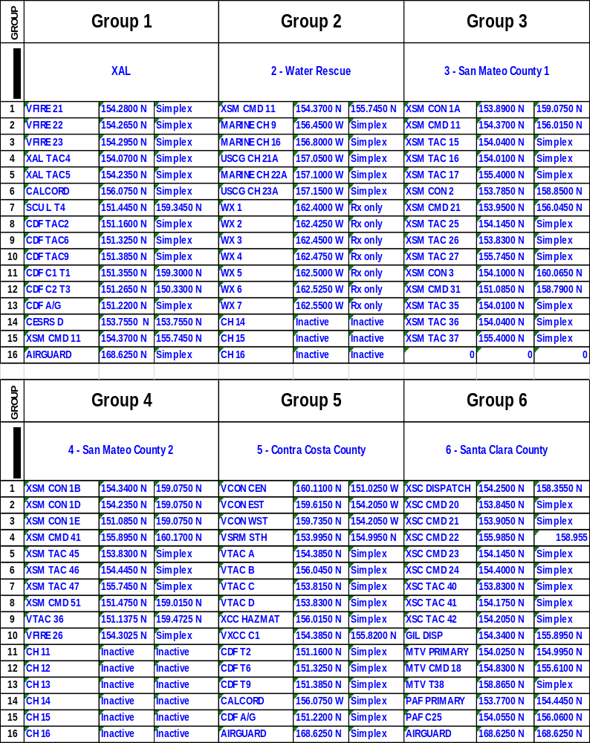

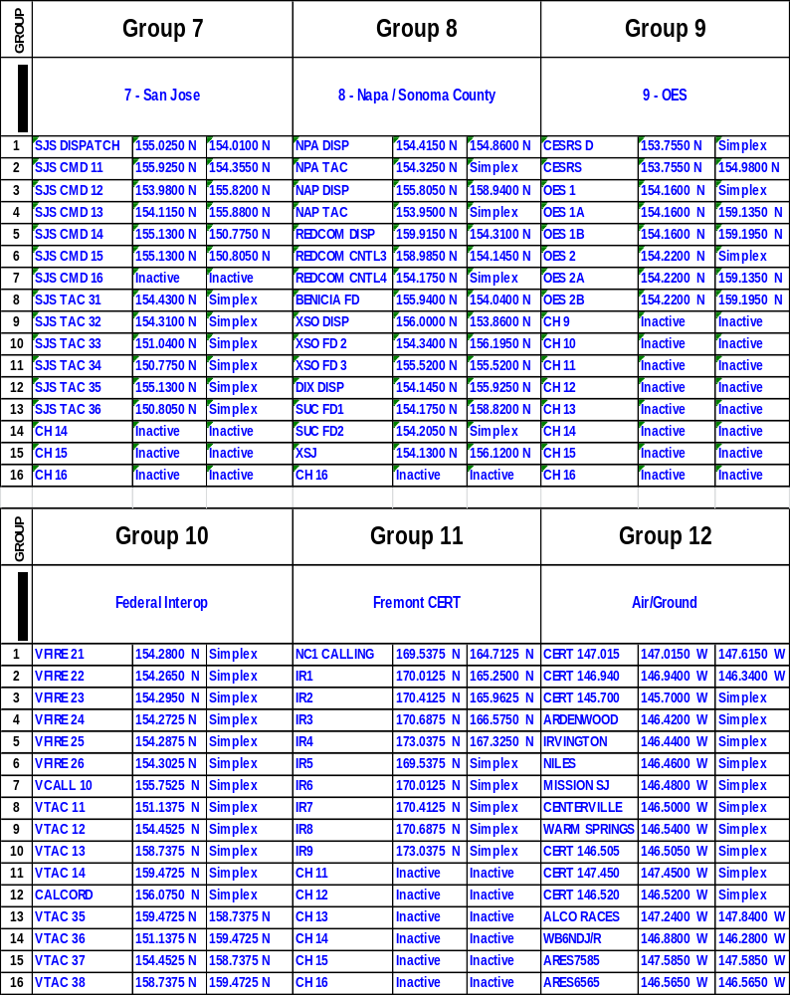
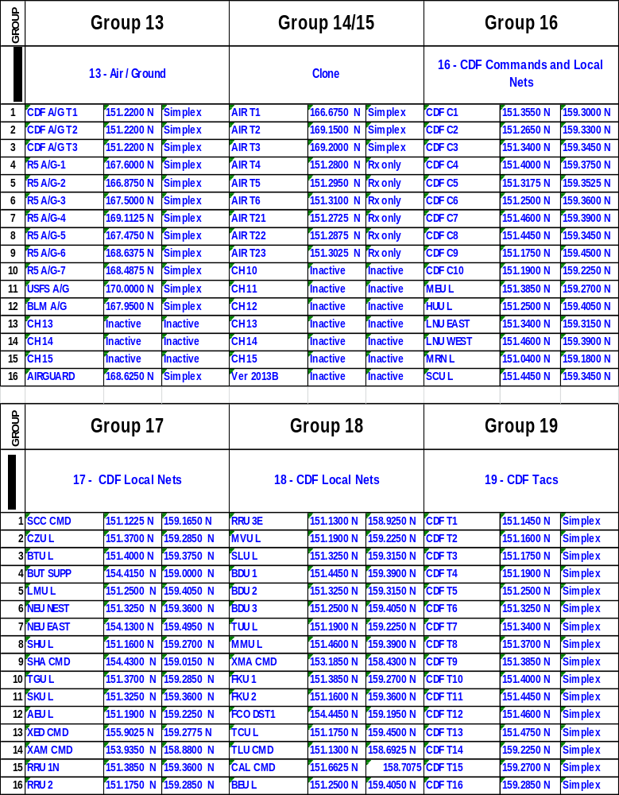
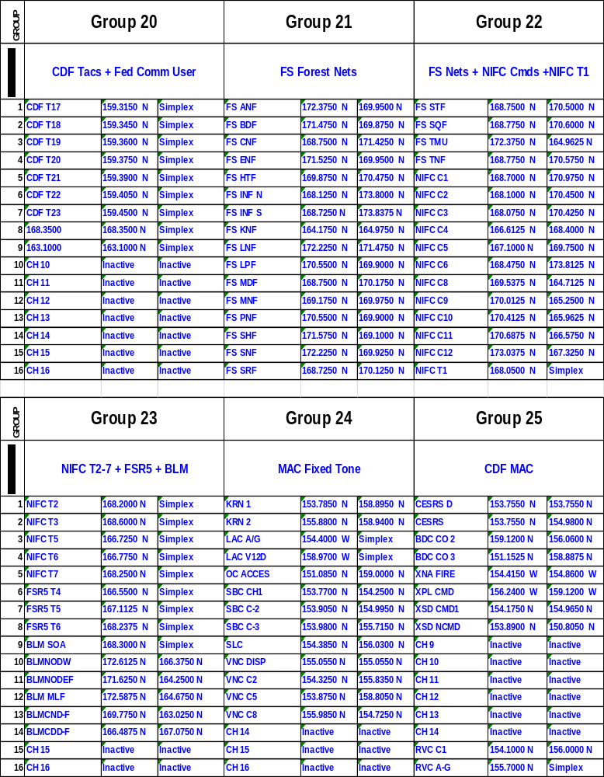

Main 48 Talk Groups for AFG Programming

With Additional Zones for the XTS / XTL 2500 or 5000

BAND | FRE | ALCO  BATT | COF | XAL | INT OP | INT OP II
1 | XAL DSP 1 | XAL DSP 1 | XAL DSP 1 | XAL DSP 1 | EB-CALL | XAL FIR1
2 | XAL DSP 2 | XAL DSP 2 | XAL DSP 2 | XAL DSP 2 | EB-INT 1 | XAL FIR2
3 | FRE CMD 5 | ACF CMD 2 | ACF CMD 8 | XAL CMD 16 | EB-INT 2 | XAL EMS1
4 | FRE TAC 25 | ACF TAC 22 | ACF TAC 28 | XAL TAC 36 | EB-INT 3 | XAL EMS2
5 | FRE TAC 45 | ACF TAC 42 | ACF TAC 48 | XAL TAC 56 | EB-INT 4 | EB FIR1
6 | FRE CMD 6 | ACF CMD 3 | COF1 | XAL CMD 17 | EB-INT 5 | EB FIR2
7 | FRE TAC 26 | ACF TAC 23 | COF 2 | XAL TAC 37 | 8CALL90 | EB EMS1
8 | FRE TAC 46 | ACF TAC 43 | FRE TRNG | XAL TAC 57 | 8CALL90D | EB EMS2
9 | XAL CMD 18 | ACF CMD 4 | FRE EXP | XAL CMD 18 | 8TAC91 | XCC FIR1
10 | XAL TAC 38 | ACF TAC 24 | South Cnty 1 | XAL TAC 38 | 8TAC91D | XCC FIR2
11 | XAL TAC 58 | ACF TAC 44 | South Cnty 2 | XAL TAC 58 | 8TAC92 | XCC EMS1
12 | ACF CMD 7 | LAP CMD 9 | XAL Trng 75 | XAL CMD 19 | 8TAC92D | XCC EMS2
13 | ACF TAC 27 | LAP TAC 29 | XAL Trng 76 | XAL TAC 39 | 8TAC93 | ALCO LAW 1
14 | ACF TAC 47 | LAP TAC 49 | BLANK | XAL TAC 59 | 8TAC93D | ALCO PW 1
15 | DIR FIR 1 | DIR FIR 3 | DIR FIR 3 | DIR FIR 1 | 8TAC94 | DIR FIR 2

BAND
  ACF | ALA | ALB | BER | EBY
  Zone G | Zone H | Zone I | Zone J | Zone K
  ALA | ALA | ALB | BER | EBY
  Zone H |  | Zone I | Zone J | Zone K
  ALB | ALA | ALB | BER | EBY
  Zone I | Zone H | Zone I | Zone J | Zone K
  BER | ALA | ALB | BER | EBY
  Zone J | Zone H | Zone I | Zone J | Zone K
  EBY | ALA | ALB | BER | EBY
  Zone K | Zone H | Zone I | Zone J | Zone K
  FRE | ALA | ALB | BER | EBY
  Zone L | Zone H | Zone I | Zone J | Zone K
1 | XAL DSP 1 | XAL DSP 1 | ALB DISP | BERDSP 1 | CON DSP C | XAL DSP 1
2 | XAL DSP 2 | ALA CMD 1 | ALBCMD10 | BERDSP 2 | CON 12 | XAL DSP 2
3 | ACF CMD 2 | ALA TAC 21 | ALBTAC30 | BER CMD 11 | CON 13 | FRE CMD 5
4 | ACF TAC 22 | ALA TAC 41 | ALBTAC50 | BER TAC 31 | CON 14 | FRE TAC 25
5 | ACF TAC 42 | XAL CMD 16 | ALB VTAC 1 | BER TAC 51 | CON 15 | FRE TAC 45
6 | ACF CMD 3 | XAL TAC 36 | ABPD PD1 | BER VTAC 1 | CON 16 | FRE CMD 6
7 | ACF TAC 23 | XAL TAC 56 | ABPDTAC2 | BER CMD 12 | CON 17 | FRE TAC 26
8 | ACF TAC 43 | XAL TRN 71 | UCB PD 1 | BER TAC 32 | CON 18 | FRE TAC 46
9 | ACF CMD 4 | APD 1 | UCB PD 2 | BER TAC 52 | CON 19 | XAL CMD 18
10 | ACF TAC 24 | APD 2 | CESRS D | BER VTAC 2 | CON 20 | XAL TAC 38
11 | ACF TAC 44 | ALA PW | VFIRE 21 | BER VTAC 3 | VFIRE 22 | XAL TAC 58
12 | ACF CMD 7 | ALA POWR | VFIRE 22 | VFIRE 22 | XCC-CC1 | ACF CMD 7
13 | ACF TAC 27 | ALA CITY 1 | VFIRE 23 | BPD 1 | CALCORD | ACF TAC 27
14 | ACF TAC 47 | ALA CITY 2 | CALCORD | UCB PD1 | XCC DIR 3 | ACF TAC 47
15 | DIR FIR 3 | DIR FIR 1 | DIR FIR 1 | DIR FIR 2 | XCC DIR 4 | DIR FIR 1

BAND | HAY  ZoneM | LAP  Zone N | OKL  Zone O | PIE  Zone P | XAL LAW  Zone Q | MCI  Zone R | XAL HOSP  Zone S
1 | HAY PRIM | XAL DSP 2 | Oakland 1 | PIE DSP | BART 1 | CMED | CMED
2 | HAY CMD 2 | LAP CMD 9 | Oakland 2 | PIE CMD 34 | ACSO 1 | XAL DSP 3 | ALAMEDA
3 | HAY CMD 13 | LAP TAC 29 | Oakland 3 | PIE CMD 35 | APD 1 | EMS CMD 20 | ALTABATE
4 | HAY CMD 14 | LAP TAC 49 | Oakland 4 | Oakland 1 | ABPD 1 | EMS TAC 40 | CHILDRNS
5 | HAY TAC 33 | XAL CMD 19 | Oakland 5 | Oakland 2 | BPD 1 | EMS TAC 60 | EDEN
6 | HAY TAC 34 | XAL TAC 39 | Oakland 6 | Oakland 3 | ACSO 2 | EMS TAC 61 | HIGHLAND
7 | HAY TAC 53 | XAL TAC 59 | Oakland 7 | Oakland 4 | EPD 1 | EMS TAC 62 | KAISR FRE
8 | HAY TAC 54 | ACF CMD 3 | Oakland 8 | Oakland 5 | FPD 1 | EMS TAC 63 | KAISR HAY
9 | HAY DSP D | ACF TAC 23 | Oakland 9 | Oakland 6 | HPD 1 | EMS TAC 64 | KAISR OAK
10 | HAY CMD D | ACF TAC 43 | Oakland 10 | Oakland 7 | LPD MAIN | EMS TAC 65 | ST ROSE
11 | HPD 1 | ACF CMD 2 | Patch T4 | Oakland 8 | PLPD MAIN | EMS TAC 66 | SN LNDRO
12 | HPD 3 | ACF TAC 22 | OPD OFD | Oakland 9 | BLANK | EMS TAC 67 | SAN RAMN
13 | HPD 5 | ACF TAC 42 | AIRPORT | Oakland 10 | BLANK | EMS TAC 68 | SUMMIT
14 | HAY 8DSP | CALCORD | OFD COM | Patch T4 | NPD 1 | DIR EMS 1 | VLLY CARE
15 | DIR FIR 2 | DIR FIR 1 | DIR FIR 3 | DIR FIR 3 | UCPD | DIR EMS 2 | WSHNGTN

BAND | TRNG 1  Zone T | TRNG 2  Zone U | IMT  Zone V | DISASTER  Zone W | 700 CONV1  Zone X | 700 CONV2  Zone Y | 700 CONV3  ZONE Z
1 | XAL TRN71 | HOME DSP | XAL ICS 1 | CAFIRE 1 | 7CALL50 | 7CALL70 | 7MOB79
2 | XAL TRN72 | XAL TRN 81 | XAL ICS 2 | CAFIRE 1D | 7CALL50D | 7CALL70D | 7MOB79D
3 | XAL TRN73 | XAL TRN 82 | XAL ICS 3 | CAFIRE 2 | 7TAC51 | 7TAC71 | 7LAW81
4 | XAL TRN74 | XAL TRN 83 | XAL ICS 4 | CAFIRE 2D | 7TAC51D | 7TAC71D | 7LAW81D
5 | XAL TRN75 | XAL TRN 84 | XAL ICS 5 | CALAW8 | 7TAC52 | 7TAC72 | 7LAW82
6 | XAL TRN76 | XAL TRN 85 | XAL ICS 6 | CALAW8D | 7TAC52D | 7TAC72D | 7LAW82D
7 | XAL TRN77 | XAL TRN 86 | XAL ICS 7 | CALAW9D | 7TAC53 | 7TAC73 | 7FIRE83
8 | XAL TRN78 | XAL TRN 87 | XAL ICS 8 | ECC2ECC | 7TAC53D | 7TAC73D | 7FIRE83D
9 | XAL TRN79 | XAL TRN 88 | XAL ICS 9 | XAL EOC | 7TAC54 | 7TAC74 | 7FIRE84
10 | XAL TRN80 | XAL TRN 89 | XAL ICS 10 | XCC EOC | 7TAC54D | 7TAC74D | 7FIRE84D
11 | BLANK | XAL TRN 90 | XAL ICS 11 | XAL N EOC | 7TAC55 | 7TAC75 | 7MED86
12 | DIR FIR 1 | XAL BLANK | XAL ICS 12 | XAL S EOC | 7TAC55D | 7TAC75D | 7MED86D
13 | DIR FIR 2 | DIR FIR 1 | XAL PREV 1 | XAL E EOC | 7TAC56 | 7TAC76 | 7MED87
14 | DIR FIR 3 | DIR FIR 2 | XAL PREV 2 | XCC C EOC | 7TAC56D | 7TAC76D | 7MED87D
15 | HOME EMRG | DIR FIR 3 | XAL PREV 3 | XCC W EOC | 7TAC57 | 7GTAC77 | BLANK

BAND | SRM  Zone AA | CON BRAVO C  Zone AB | CON CHARLIE E  Zone AC | CON DELTA  Zone AD | CON ECHO  Zone AE | CON FOXTROT  Zone AF | CON NOV  Zone AG
1 | SRM DISP | CON DSP C | CON DSP E | V CENT | CON DSP W | RMD DSP | XCC-EMS 1
2 | VSRM STH | CON 2 | CON 12 | V EAST | CON 22 | RMD 2 | XCC-EMS 2
3 | VSRM SALT | CON 3 | CON 13 | V WEST | CON 23 | RMD 3 | XCC-EMS 3
4 | SRM 4 | CON 4 | CON 14 | VSRM S | CON 24 | RMD 4 | XCC-EMS 4
5 | SRM 5 | CON 5 | CON 15 | SCU L T1 | CON 25 | RMD 5 | JMMC WC
6 | SRM 6 | CON 6 | CON 16 | CDF C1T1 | CON 26 | RMD 6 | JMMC CON
7 | SRM 7 | CON 7 | CON 17 | CDF T2 | CON 27 | CON DISP | SRMC
8 | SRM 8 | CON 8 | CON 18 | CDF T6 | CON 28 | RMD ADMN | KWC
9 | XCC DIR 1 | CON 9 | CON 19 | CDF T9 | CON 29 | RPD 1 | COUNTY
10 | XCC DIR 3 | CON 10 | CON 20 | VFIRE21 | RMD DSP | EKS PD | KANT
11 | VFIRE 22 | VFIRE 22 | VFIRE 22 | VFIRE22 | VFIRE 22 | CCSO W | DELTA
12 | XCC-CC1 | XCC-CC1 | XCC-CC1 | VFIRE23 | XCC-CC1 | XCC-CC1 | KRMD
13 | CALCORD | CALCORD | CALCORD | VFIRE26 | CALCORD | CALCORD | DOCTORS
14 | XCC DIR 5 | XCC DIR 1 | XCC DIR 3 | CALCORD | XCC DIR 1 | RMD DIR | XCC COM1
15 | VSRM S D | XCC DIR 2 | XCC DIR 4 | CDF AGT2 | XCC DIR 2 | XCC DIR 4 | XCC CMD1

BAND | CON OSCAR  AH | ALCO “A”  AI | ALCO "B"  AJ | ALCO "C"  AK | Blank | Blank | COF  ZZ
1 | XCC ICS 1 | CTRL 1 | CTRL 2 | IA LAW |  |  | FPD Patrol 1
2 | XCC ICS 2 | CTRL 2 | LPFD | IAFIRE |  |  | FPD Patrol 2
3 | XCC ICS 3 | CTRL 3 | LPFDT2 | IA EMS |  |  | FPD Patrol 3
4 | XCC ICS 4 | CTRL 4 | LPFDT3 | IA PW |  |  | FPD Patrol 4
5 | XCC ICS 5 | TAC 5 | LPFDT4 | 8CALL90D |  |  | FPD SWAT
6 | XCC ICS 6 | TAC 6 | HFD 1 | 8TAC91D |  |  | EOC/FOC
7 | XCC ICS 7 | TAC 7 | HFD 2 | 8TAC92D |  |  | FRE PW
8 | XCC ICS 8 | TAC 8 | NFD 1 | 8TAC93D
9 | XCC ICS 9 | TAC 9 | NFD 2 | 8TAC94D
10 | XCC ICS 10 | TAC 10 | TAC 16 | CALAW8D
11 | XCC ICS 11 | TAC 11 | TAC 17 | CAFIRE1D
12 | XCC ICS 12 | TAC 12 | AMR N | CALAW9D
13 | XCC ICS 13 | TAC 13 | AMR S | CAFIRE2D
14 | XCC ICS 14 | TAC 14 | ACSO 1 | MATAC1
15 | XCC ICS 15 | TAC 15 | SLPD 1 | MATAC2
** Note: Zones AI, AJ, AK are only temporary until all programing is complete and the switch to the new radio system is made.

